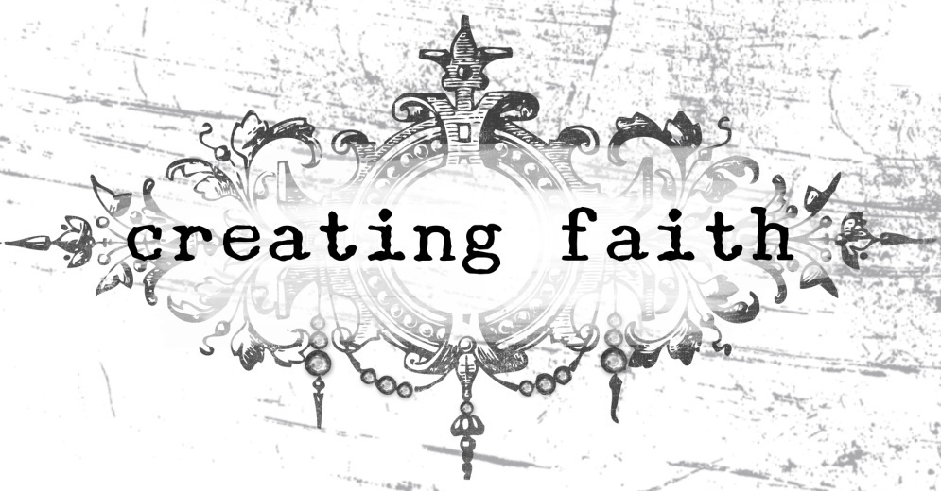
Time to breathe.
Time to create.
Time to let the worry go.

Come and join us for a day of reflection and creation, while learning to let go of the worries that plague the life of the modern mother.

Snacks, lunch, prayer, laughter, and creating included.
$35.00
Limited to the first 25 participants

June 5, 2010
9:00am-3:30pm
Our Savior’s Lutheran Church
Sun Prairie, WI
www.oslc-elca.org

Hosted by Stephenie Hamen
www.mycraftyadventures.com

Creating Faith
June 5, 2010

Name ________________________________________

Address ________________________________________

Phone ________________________________________

Email ________________________________________

Please make checks payable to:
Our Savior’s Lutheran Church
550 Lincoln Drive
Sun Prairie, WI 53590

